Micro laser engraving machine XD1213

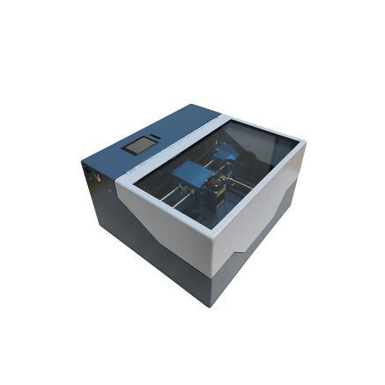

Its features are that the body is small and exquisite, easy to place and carry, and can be designed and modeled on a computer or mobile phone using a simple program, and then the seal can be quickly made by connecting to the micro-engraving machine through a USB interface or Bluetooth. It enables primary and secondary school students and seal carving enthusiasts to instantly turn their broad design imagination into reality, and also enjoy the fun of high-tech application in the production process.

Applicable materials (engraving):

Acrylic, plexiglass, plastic, crystal, wood, medium-density fiberboard, density board, bamboo products, two-color board, window paper, cardboard, leather, cloth, wool, clothing accessories, chemical composition fabrics, embroidery, shells, coconut shells, horns, resins, animal sebum, polyethylene materials, ABS boards, lampshades, coated metals, etc.

Scope of application:

Campus maker rooms, general technology teaching in ordinary high schools, comprehensive practice rooms, model design and production courses, CNC majors in vocational schools, CNC majors in technical schools, etc.

The full sheet metal shell design is hard and resistant to falling, and the surface is sprayed with high temperature technology, which is scratch-resistant and easy to clean;

The frame adopts the full aluminum alloy oxidation process, the surface is flat and smooth, the stainless steel cylindrical guide rail, the material is wear-resistant and hard, and the imported rust-proof linear slider is smooth and accurate;

It can be used with a small metal machine tool to teach seal engraving;

USB and Bluetooth file transfer function;

Each laser engraving machine is equipped with two pairs of goggles to protect the user's eyes.

Laser Travel: 120130mm  
Typing Speed: 500mm/min  
Engraving Speed: 800mm/min, 10-15/mm  
Minimum English/Number Size: 1.5mm  
Minimum Chinese Size: 3mm  
Laser Power: 2.5W  
Power Supply: 12V 3A  
Engraving Materials: Wood, thin PVC boards  
Dimensions: 320300\*165mm  
Net Weight: 4.5kg